In SE11, Go to the Emp table .

Create a domain for Job, if not done already.

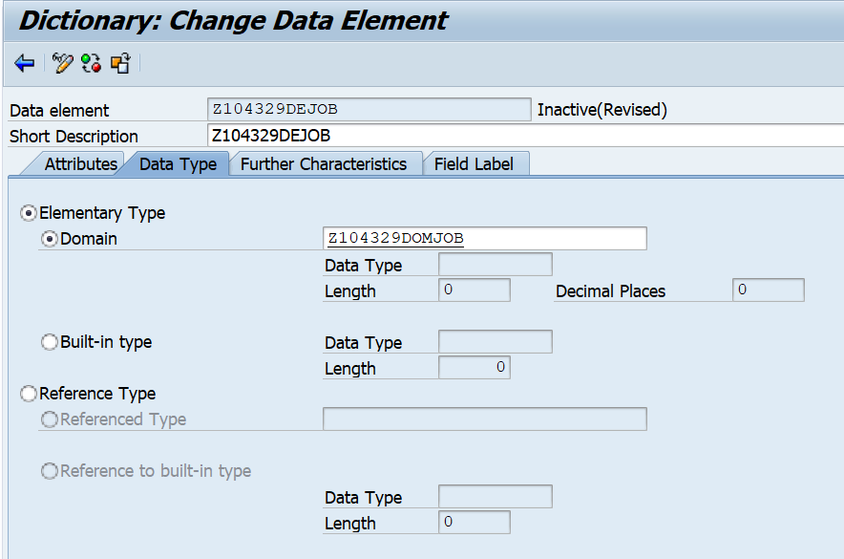

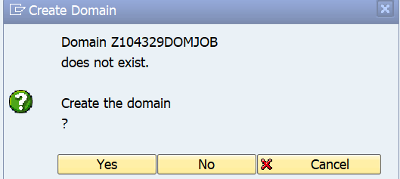

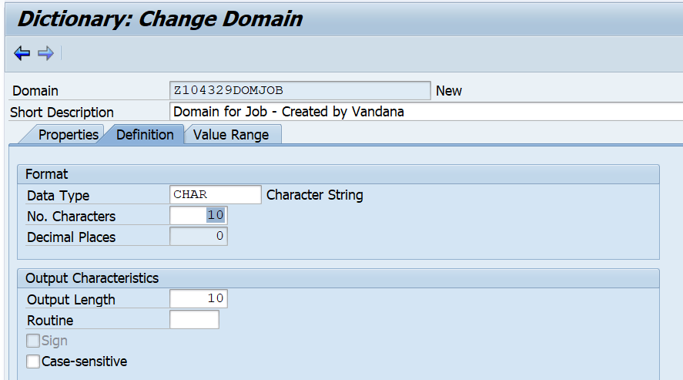

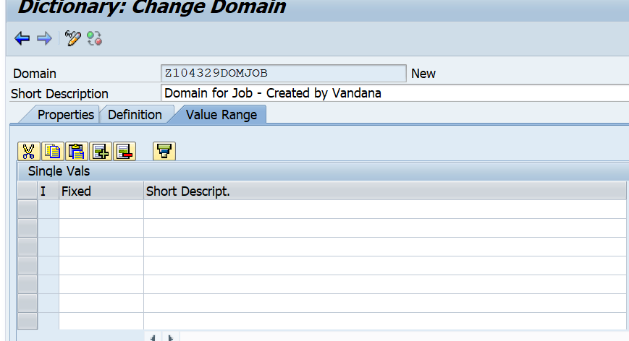

Value range- Fixed values can be given here. But the list cannot be exhaustive.

Hence, the need to create a value table.

1. Create a Value table.
2. Go to SE11.
3. Create table as shown below.

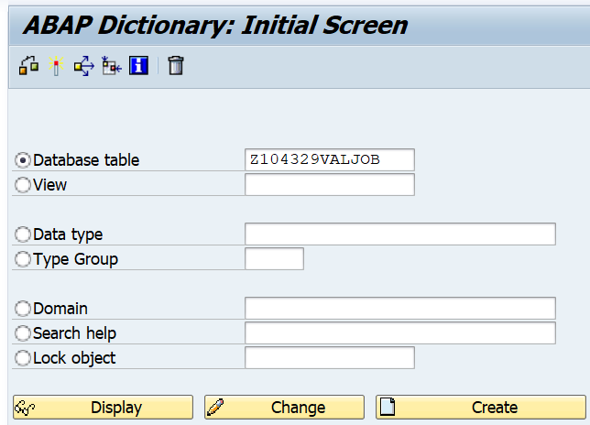

1. Define structure as shown below. The data element and domain is the same as Emp table – Field Job.

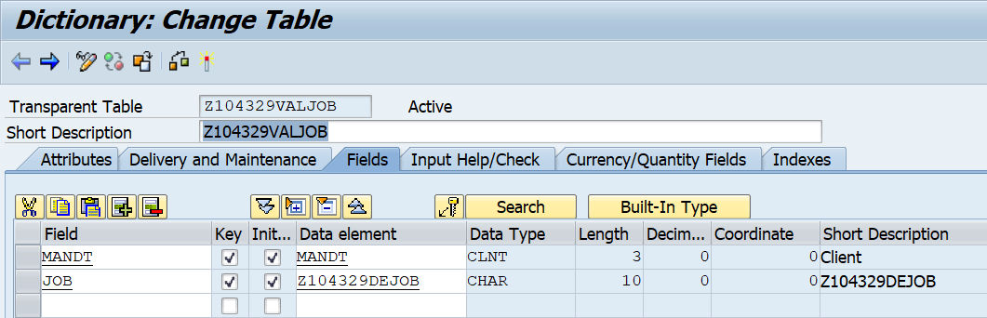

1. Enter records as shown below.

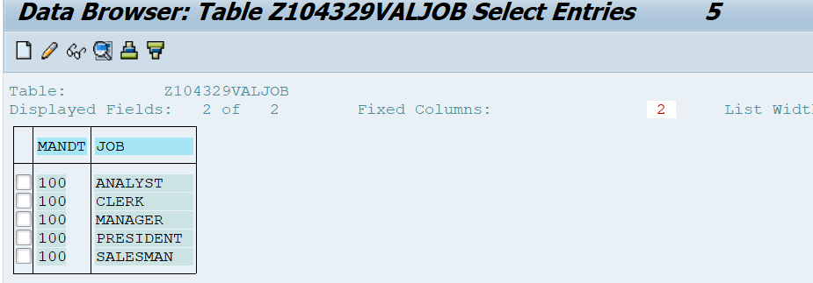

1. Refer to the Value table in Emp table.
2. Go to SE11, EMP table.
3. Go to the domain for Job. Enter the value table name.

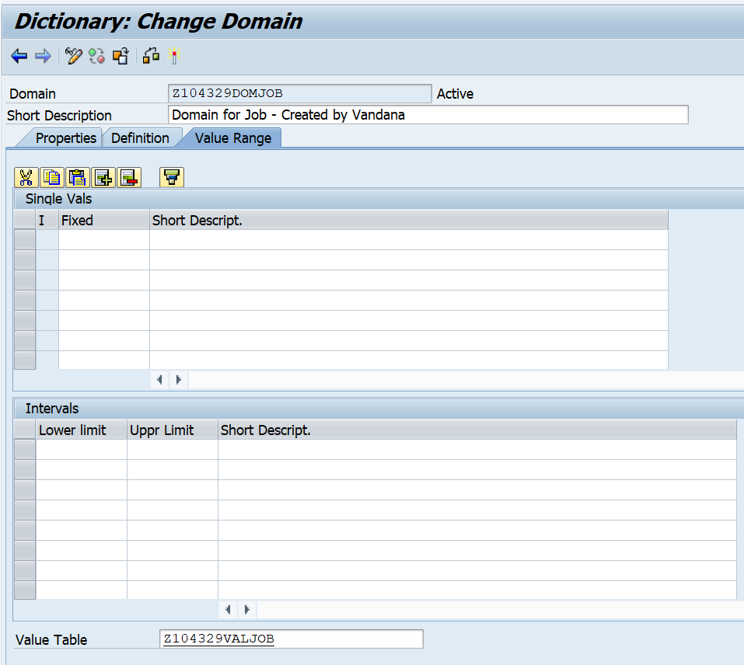

1. Activate Domain, data element. Table.
2. Enter values in the Emp table. Here the values of Job must be taken from the value table.

However, this does **NOT** happen here.

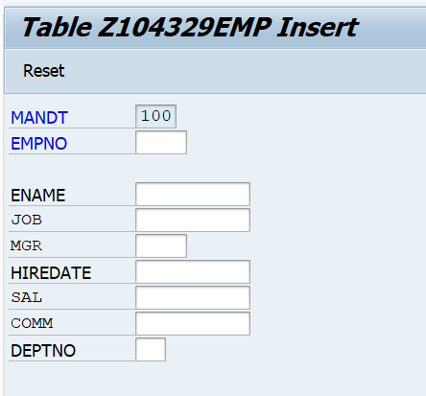

1. Create a relationship with the Job table. Go the Emp table.

Select job field. Click on foreign key. You will see a dialog box as shown below.

Select Yes.

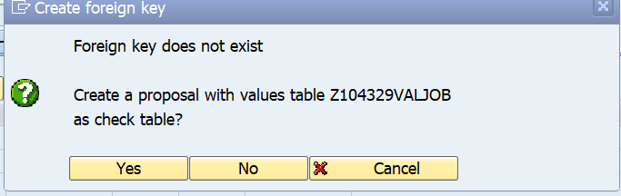

1. The check table and value table fields are displayed as shown below. Click on copy.

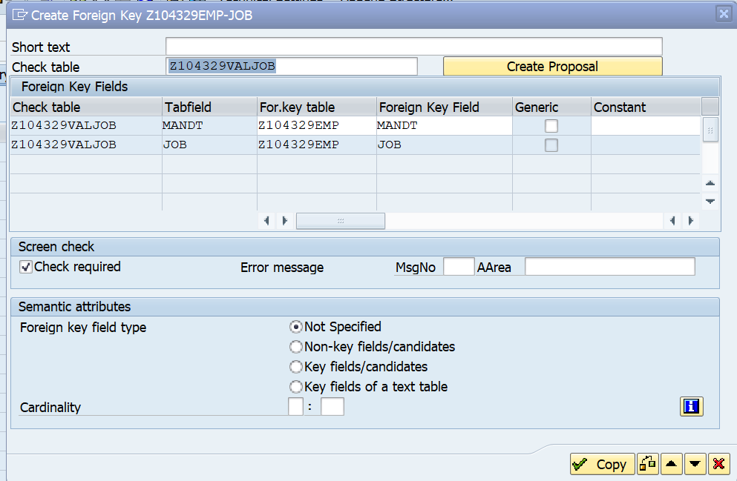

1. Save and Activate the Emp table.
2. Enter values in the Emp table. Here the values of Job must be taken from the value table.

